TASK 6: MULTIMIDIA NARRATIVE
STUDENT: AIMEE COSTA
WEEK: SEPTEMBER 12 TO 16

How it all started…

I started learning English when I was 9 years old, but I believe
I fell in love with the language back when I was 5 or 6, and started going to the movies with my parents. I have clear memories of “Herbie” ( Se meu Fusca falasse), the first version, like 30 years ago….Oops, I think I have just confessed my Jurassic age…

(http://disney.go.com/disneypictures/herbie/)
Also, “The Enchanted Mountain” was neat as well as the “Trinity” series ( “ My name is Trinity” ) a kind of farwest comedy series we were just crazy about. It felt really strange to go see those films and know nothing about that language. My father, who is a funny person, used to say that he could speak English, and it took me years to find out his English knowledge was restricted to adding the suffix “ation” to everything you could think of, and of course, “rolling” his tongue to any “r” sound he could grasp in the words.

My schools and I…

But, no matter how flaky my father’s English was, he was a great enthusiast of languages, so I had his full support in order to learn English…decently, let’s say! So, there I went, to my first year of a long story of love with the language, to my first formal English classes, at the ETIMIG school (Escola de Tradutores e Intérpretes de Minas Gerais). The method was pretty much audiolingual, we used to have lots of “slide shows”, we had to repeat dialogues and role play them with our classmates also. I loved it! Every class was a new discovery, a new word, a new lesson… I was thrilled, and I worked hard to improve my skills and feel more comfortable with the language.



But I have to confess, I have never been shy, any chance I had to speak, to interact, to suggest something or give my opinion was truly appreciated…by me, mainly! For me, anything was a great excuse to use what I had learned.

I spent 2 years at ETIMIG and then moved to ICBEU (Instituto Cultural Brasil-Estados Unidos/ http://www.icbeu.com.br ), a school where I would spend the next 6 years of my life studying English and making friends, learning lots of new things and having a new perspective of the language. There, we had lots of good quality reading and at the age of 12, there I was reading Irwin Shaw, Somerset Maugham and Shakespeare’s short adaptations, amazed and delighted about every piece of it…




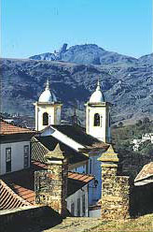And then came the trips…

The first place I remember fully using my little
knowledge of English language was in Ouro
Preto, this gorgeous historical city close to
Belo, famous for its history and lots of foreign
tourists, so whenever I went there I tried to
dig a chance to speak. I wanted real life
experiences, real usage of the language
I loved to speak…

After that, I started traveling abroad and improving my fluency and the vocabulary files in my mind. The more I traveled, the more at ease I felt about speaking, listening and expressing myself, in all circumstances. I have traveled so far to many different places, mainly in the United States, where my fiancé lives. We went to Texas, Arizona, North Carolina, New York, Tennessee, Pennsylvania, Alaska, California, England and , funny enough, when we were in Mexico trying to speak our poor Spanish with the Mexicans, guess what, nobody wanted to do that, they wanted to practice their English with us…That was a little disappointing!

Well, that’s it for now, but I still have lots of memories and thoughts about my learning process and love affair with this beautiful language: English!
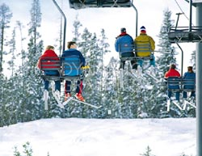



USA



Capitol, Washington DC
+

Big Ben, London

The next chapter of my Multimidia Narrative will be dedicated to:

The songs of my English story…

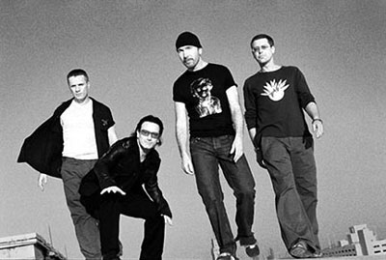

I Still Haven’t Found What I’m Looking For
U2
Composição: U2

I have climbed the highest mountains
I have run through the fields
Only to be with you (x 2)

I have run I have crawled
I have scaled
These city walls (x 2)
Only to be with you

Chorus:
But I still haven’t found
What I’m looking for
But I still haven’t found
What I’m looking for

I have kissed honey lips
Felt the healing in her fingertips
It burned like fire
This burning desire

I have spoken with the tongue of angels
I have held the hand of the devil
It was warm in the night
It was cold as a stone

Chorus

I believed in the kingdom come
Then all the colours will
Bleed into one (x 2)
But yes I’m still running

You broke the bonds and you loosed the chains
You carried the cross
And my shame (x 2)
You know I believed it

Chorus (x 2)

To listen to the song, just click here:
Musica do U2-I Still Haven't Found What I'm Looking For

